Demographic Sentencing Disparities Baseline Switch
January 26, 2022
This document attempts to replicate the Commission’s “refined model” for estimating demographic disparities in sentencing. For more information about the model and for the reference regressions, see “Demographic Disparities Baseline Switch Reference Docs.” For a write-up of findings, see the latest version of the Data Learnings Memo.

White Male Baseline Regressions

Post-Protect
 | Estimate | Standard Error | t value | Pr(>|t|)
(Intercept) | 0.698 | 0.046 | 15.108 | 0.0000 | ***
logmin | 0.667 | 0.004 | 162.813 | 0.0000 | ***
drugtraffTRUE | 0.182 | 0.028 | 6.406 | 0.0000 | ***
sexual2TRUE | 0.213 | 0.102 | 2.082 | 0.0373 | *
pornTRUE | 0.209 | 0.089 | 2.337 | 0.0195 | *
immigrationTRUE | 0.131 | 0.036 | 3.651 | 0.0003 | ***
othtype2TRUE | -0.117 | 0.046 | -2.563 | 0.0104 | *
whitecollTRUE | -0.479 | 0.034 | -14.277 | 0.0000 | ***
upwardTRUE | 1.508 | 0.089 | 16.867 | 0.0000 | ***
downdepTRUE | -0.931 | 0.027 | -34.633 | 0.0000 | ***
subasstTRUE | -1.091 | 0.026 | -41.662 | 0.0000 | ***
mandmin2TRUE | 0.159 | 0.030 | 5.253 | 0.0000 | ***
NEWCNVTN | 0.280 | 0.042 | 6.609 | 0.0000 | ***
custodyTRUE | 0.728 | 0.022 | 33.253 | 0.0000 | ***
relevel(factor(racesex), ref = 8)blackfemale | -0.295 | 0.048 | -6.186 | 0.0000 | ***
relevel(factor(racesex), ref = 8)blackmale | 0.124 | 0.026 | 4.791 | 0.0000 | ***
relevel(factor(racesex), ref = 8)hispfemale | -0.219 | 0.049 | -4.486 | 0.0000 | ***
relevel(factor(racesex), ref = 8)hispmale | 0.010 | 0.028 | 0.363 | 0.7166
relevel(factor(racesex), ref = 8)otherfemale | -0.565 | 0.102 | -5.538 | 0.0000 | ***
relevel(factor(racesex), ref = 8)othermale | -0.080 | 0.054 | -1.484 | 0.1379
relevel(factor(racesex), ref = 8)whitefemale | -0.308 | 0.042 | -7.294 | 0.0000 | ***
agedummyTRUE | 0.031 | 0.021 | 1.531 | 0.1257
educTRUE | -0.100 | 0.022 | -4.483 | 0.0000 | ***
citizenTRUE | -0.084 | 0.027 | -3.158 | 0.0016 | **
Signif. codes: 0 <= '***' < 0.001 < '**' < 0.01 < '*' < 0.05
Residual standard error: 1.358 on 25587 degrees of freedom
Multiple R-squared: 0.6976, Adjusted R-squared: 0.6973
F-statistic: 2566 on 25587 and 23 DF, p-value: 0.0000

Post-Booker
 | Estimate | Standard Error | t value | Pr(>|t|)
(Intercept) | 0.503 | 0.017 | 29.030 | 0.0000 | ***
logmin | 0.700 | 0.002 | 421.092 | 0.0000 | ***
drugtraffTRUE | 0.207 | 0.010 | 20.275 | 0.0000 | ***
sexual2TRUE | 0.134 | 0.038 | 3.545 | 0.0004 | ***
pornTRUE | 0.418 | 0.025 | 16.664 | 0.0000 | ***
immigrationTRUE | 0.149 | 0.013 | 11.546 | 0.0000 | ***
othtype2TRUE | -0.443 | 0.018 | -25.132 | 0.0000 | ***
whitecollTRUE | -0.335 | 0.012 | -27.253 | 0.0000 | ***
upwardTRUE | 0.982 | 0.025 | 39.962 | 0.0000 | ***
downdepTRUE | -0.916 | 0.008 | -116.794 | 0.0000 | ***
subasstTRUE | -1.083 | 0.010 | -107.939 | 0.0000 | ***
mandmin2TRUE | 0.195 | 0.010 | 18.923 | 0.0000 | ***
NEWCNVTN | 0.312 | 0.015 | 20.949 | 0.0000 | ***
custodyTRUE | 0.761 | 0.008 | 91.017 | 0.0000 | ***
relevel(factor(racesex), ref = 8)blackfemale | -0.293 | 0.018 | -16.055 | 0.0000 | ***
relevel(factor(racesex), ref = 8)blackmale | 0.156 | 0.010 | 16.392 | 0.0000 | ***
relevel(factor(racesex), ref = 8)hispfemale | -0.265 | 0.017 | -15.354 | 0.0000 | ***
relevel(factor(racesex), ref = 8)hispmale | -0.009 | 0.010 | -0.886 | 0.3756
relevel(factor(racesex), ref = 8)otherfemale | -0.251 | 0.034 | -7.372 | 0.0000 | ***
relevel(factor(racesex), ref = 8)othermale | 0.039 | 0.018 | 2.164 | 0.0305 | *
relevel(factor(racesex), ref = 8)whitefemale | -0.215 | 0.015 | -14.071 | 0.0000 | ***
agedummyTRUE | 0.042 | 0.008 | 5.401 | 0.0000 | ***
educTRUE | -0.060 | 0.008 | -7.299 | 0.0000 | ***
citizenTRUE | -0.071 | 0.010 | -7.213 | 0.0000 | ***
Signif. codes: 0 <= '***' < 0.001 < '**' < 0.01 < '*' < 0.05
Residual standard error: 1.347 on 190914 degrees of freedom
Multiple R-squared: 0.6755, Adjusted R-squared: 0.6755
F-statistic: 1.728e+04 on 190914 and 23 DF, p-value: 0.0000

Post-Gall
 | Estimate | Standard Error | t value | Pr(>|t|)
(Intercept) | 0.550 | 0.017 | 32.447 | 0.0000 | ***
logmin | 0.631 | 0.001 | 422.107 | 0.0000 | ***
drugtraffTRUE | 0.143 | 0.010 | 14.207 | 0.0000 | ***
sexual2TRUE | 0.168 | 0.037 | 4.590 | 0.0000 | ***
pornTRUE | 0.554 | 0.021 | 26.261 | 0.0000 | ***
immigrationTRUE | 0.102 | 0.012 | 8.251 | 0.0000 | ***
othtype2TRUE | -0.693 | 0.017 | -41.184 | 0.0000 | ***
whitecollTRUE | -0.368 | 0.012 | -30.477 | 0.0000 | ***
upwardTRUE | 0.880 | 0.021 | 41.568 | 0.0000 | ***
downdepTRUE | -0.969 | 0.007 | -139.554 | 0.0000 | ***
subasstTRUE | -1.021 | 0.010 | -101.740 | 0.0000 | ***
mandmin2TRUE | 0.412 | 0.010 | 42.067 | 0.0000 | ***
NEWCNVTN | 0.410 | 0.016 | 26.005 | 0.0000 | ***
custodyTRUE | 0.958 | 0.008 | 116.675 | 0.0000 | ***
relevel(factor(racesex), ref = 8)blackfemale | -0.415 | 0.019 | -22.351 | 0.0000 | ***
relevel(factor(racesex), ref = 8)blackmale | 0.174 | 0.009 | 18.458 | 0.0000 | ***
relevel(factor(racesex), ref = 8)hispfemale | -0.213 | 0.016 | -13.320 | 0.0000 | ***
relevel(factor(racesex), ref = 8)hispmale | 0.009 | 0.010 | 0.980 | 0.3270
relevel(factor(racesex), ref = 8)otherfemale | -0.432 | 0.034 | -12.515 | 0.0000 | ***
relevel(factor(racesex), ref = 8)othermale | 0.002 | 0.018 | 0.109 | 0.9132
relevel(factor(racesex), ref = 8)whitefemale | -0.384 | 0.015 | -26.319 | 0.0000 | ***
agedummyTRUE | 0.042 | 0.008 | 5.500 | 0.0000 | ***
educTRUE | -0.060 | 0.008 | -7.489 | 0.0000 | ***
citizenTRUE | -0.089 | 0.009 | -9.389 | 0.0000 | ***
Signif. codes: 0 <= '***' < 0.001 < '**' < 0.01 < '*' < 0.05
Residual standard error: 1.497 on 270474 degrees of freedom
Multiple R-squared: 0.6019, Adjusted R-squared: 0.6019
F-statistic: 1.778e+04 on 270474 and 23 DF, p-value: 0.0000

Post-Report
 | Estimate | Standard Error | t value | Pr(>|t|)
(Intercept) | 0.243 | 0.017 | 13.917 | 0.0000 | ***
logmin | 0.617 | 0.001 | 415.914 | 0.0000 | ***
drugtraffTRUE | 0.159 | 0.010 | 16.240 | 0.0000 | ***
sexual2TRUE | 0.220 | 0.030 | 7.290 | 0.0000 | ***
pornTRUE | 0.597 | 0.019 | 30.660 | 0.0000 | ***
immigrationTRUE | -0.062 | 0.012 | -5.018 | 0.0000 | ***
othtype2TRUE | -0.612 | 0.016 | -38.608 | 0.0000 | ***
whitecollTRUE | -0.223 | 0.012 | -19.022 | 0.0000 | ***
upwardTRUE | 0.675 | 0.020 | 34.259 | 0.0000 | ***
downdepTRUE | -1.033 | 0.007 | -154.793 | 0.0000 | ***
subasstTRUE | -1.095 | 0.010 | -109.557 | 0.0000 | ***
mandmin2TRUE | 0.477 | 0.010 | 49.090 | 0.0000 | ***
NEWCNVTN | 0.506 | 0.016 | 30.930 | 0.0000 | ***
custodyTRUE | 1.349 | 0.008 | 164.483 | 0.0000 | ***
relevel(factor(racesex), ref = 8)blackfemale | -0.354 | 0.018 | -19.675 | 0.0000 | ***
relevel(factor(racesex), ref = 8)blackmale | 0.167 | 0.010 | 17.444 | 0.0000 | ***
relevel(factor(racesex), ref = 8)hispfemale | -0.192 | 0.015 | -12.912 | 0.0000 | ***
relevel(factor(racesex), ref = 8)hispmale | 0.044 | 0.010 | 4.529 | 0.0000 | ***
relevel(factor(racesex), ref = 8)otherfemale | -0.443 | 0.032 | -13.972 | 0.0000 | ***
relevel(factor(racesex), ref = 8)othermale | -0.047 | 0.017 | -2.712 | 0.0067 | **
relevel(factor(racesex), ref = 8)whitefemale | -0.356 | 0.014 | -24.607 | 0.0000 | ***
agedummyTRUE | 0.035 | 0.008 | 4.494 | 0.0000 | ***
educTRUE | -0.003 | 0.008 | -0.391 | 0.6956
citizenTRUE | -0.040 | 0.009 | -4.295 | 0.0000 | ***
Signif. codes: 0 <= '***' < 0.001 < '**' < 0.01 < '*' < 0.05
Residual standard error: 1.616 on 329647 degrees of freedom
Multiple R-squared: 0.5662, Adjusted R-squared: 0.5662
F-statistic: 1.871e+04 on 329647 and 23 DF, p-value: 0.0000

Present
 | Estimate | Standard Error | t value | Pr(>|t|)
(Intercept) | 0.215 | 0.022 | 9.735 | 0.0000 | ***
logmin | 0.489 | 0.002 | 280.842 | 0.0000 | ***
drugtraffTRUE | 0.233 | 0.012 | 20.085 | 0.0000 | ***
sexual2TRUE | 0.386 | 0.036 | 10.700 | 0.0000 | ***
pornTRUE | 0.739 | 0.024 | 30.569 | 0.0000 | ***
immigrationTRUE | -0.344 | 0.015 | -23.462 | 0.0000 | ***
othtype2TRUE | -0.694 | 0.020 | -34.789 | 0.0000 | ***
whitecollTRUE | -0.161 | 0.015 | -10.801 | 0.0000 | ***
upwardTRUE | 0.732 | 0.022 | 32.837 | 0.0000 | ***
downdepTRUE | -0.995 | 0.008 | -119.850 | 0.0000 | ***
subasstTRUE | -0.896 | 0.014 | -65.678 | 0.0000 | ***
mandmin2TRUE | 0.694 | 0.012 | 58.190 | 0.0000 | ***
NEWCNVTN | 0.629 | 0.023 | 27.456 | 0.0000 | ***
custodyTRUE | 1.727 | 0.010 | 167.983 | 0.0000 | ***
relevel(factor(racesex), ref = 8)blackfemale | -0.603 | 0.025 | -24.024 | 0.0000 | ***
relevel(factor(racesex), ref = 8)blackmale | 0.146 | 0.012 | 12.224 | 0.0000 | ***
relevel(factor(racesex), ref = 8)hispfemale | -0.153 | 0.018 | -8.480 | 0.0000 | ***
relevel(factor(racesex), ref = 8)hispmale | 0.108 | 0.013 | 8.493 | 0.0000 | ***
relevel(factor(racesex), ref = 8)otherfemale | -0.583 | 0.040 | -14.723 | 0.0000 | ***
relevel(factor(racesex), ref = 8)othermale | -0.054 | 0.022 | -2.497 | 0.0125 | *
relevel(factor(racesex), ref = 8)whitefemale | -0.420 | 0.019 | -22.154 | 0.0000 | ***
agedummyTRUE | 0.092 | 0.010 | 9.278 | 0.0000 | ***
educTRUE | -0.016 | 0.010 | -1.630 | 0.1030
citizenTRUE | -0.040 | 0.012 | -3.396 | 0.0007 | ***
Signif. codes: 0 <= '***' < 0.001 < '**' < 0.01 < '*' < 0.05
Residual standard error: 1.692 on 236977 degrees of freedom
Multiple R-squared: 0.5316, Adjusted R-squared: 0.5315
F-statistic: 1.169e+04 on 236977 and 23 DF, p-value: 0.0000

Demographic Disparities in Sentencing: Bar Graphs

White Male Baseline
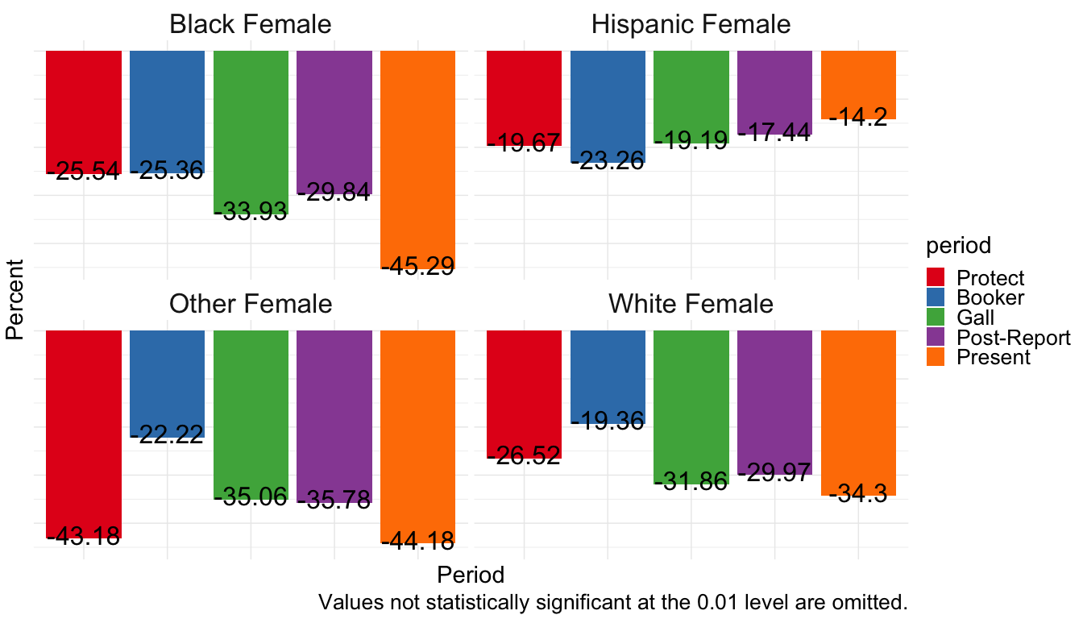
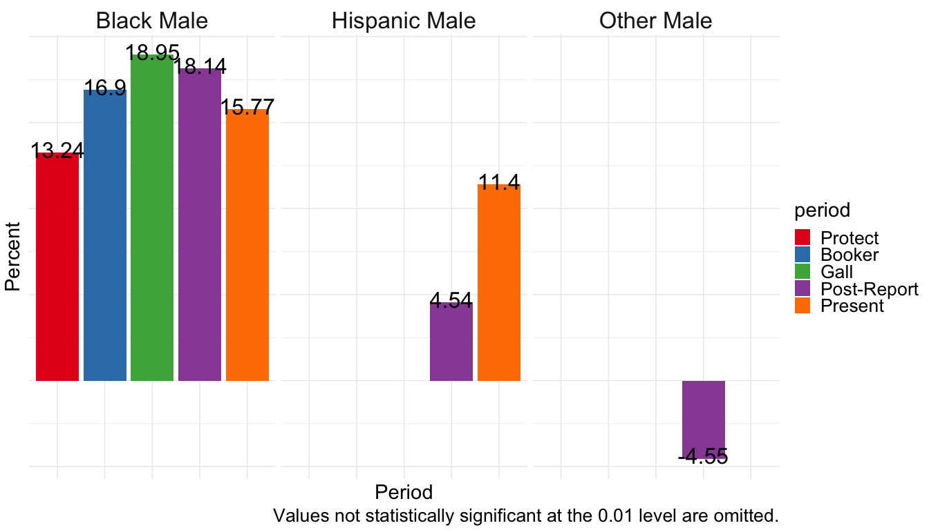

White Female Baseline
Note the colors are scrambled slightly where no statistically significant difference in groups exists during the Protect period.
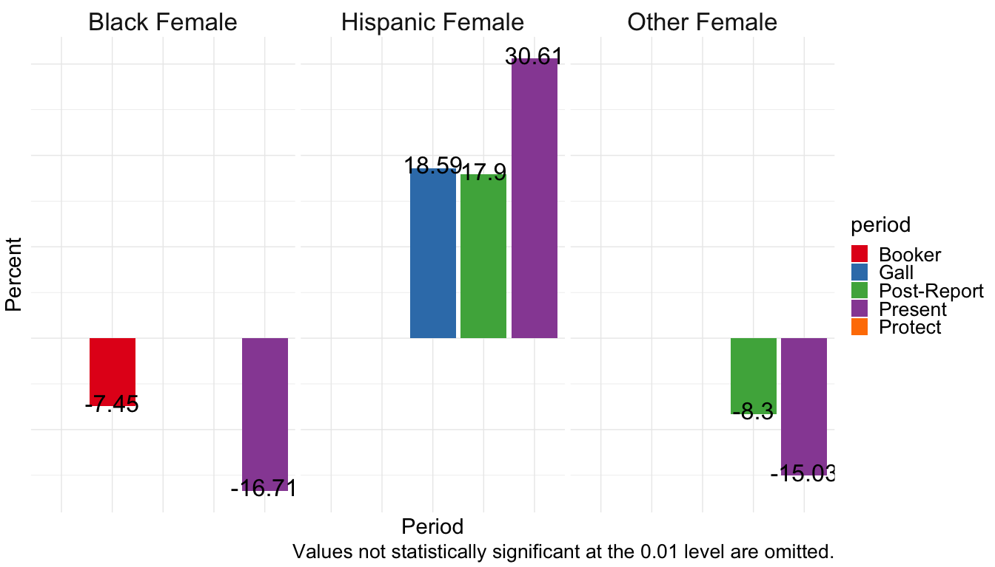
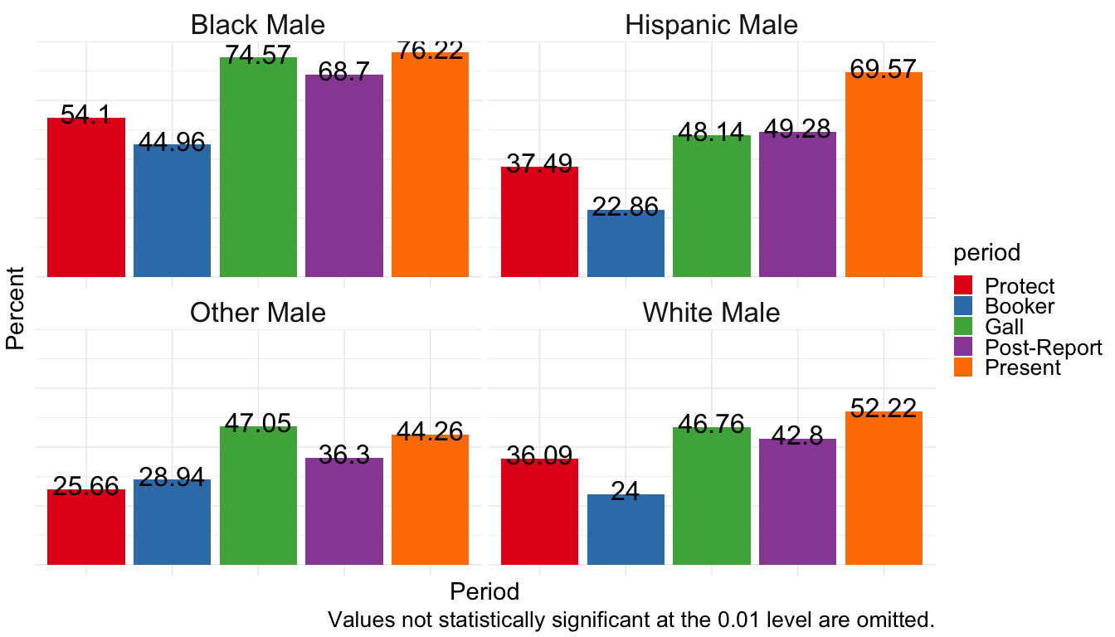

Hispanic Female Baseline
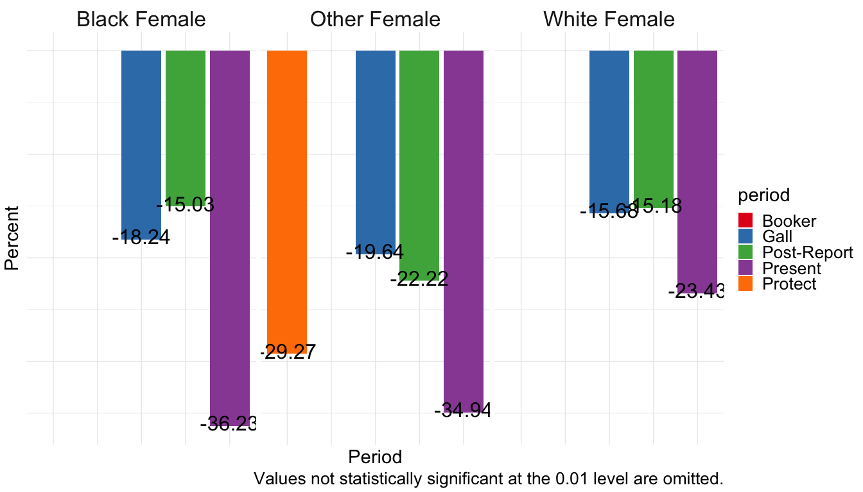
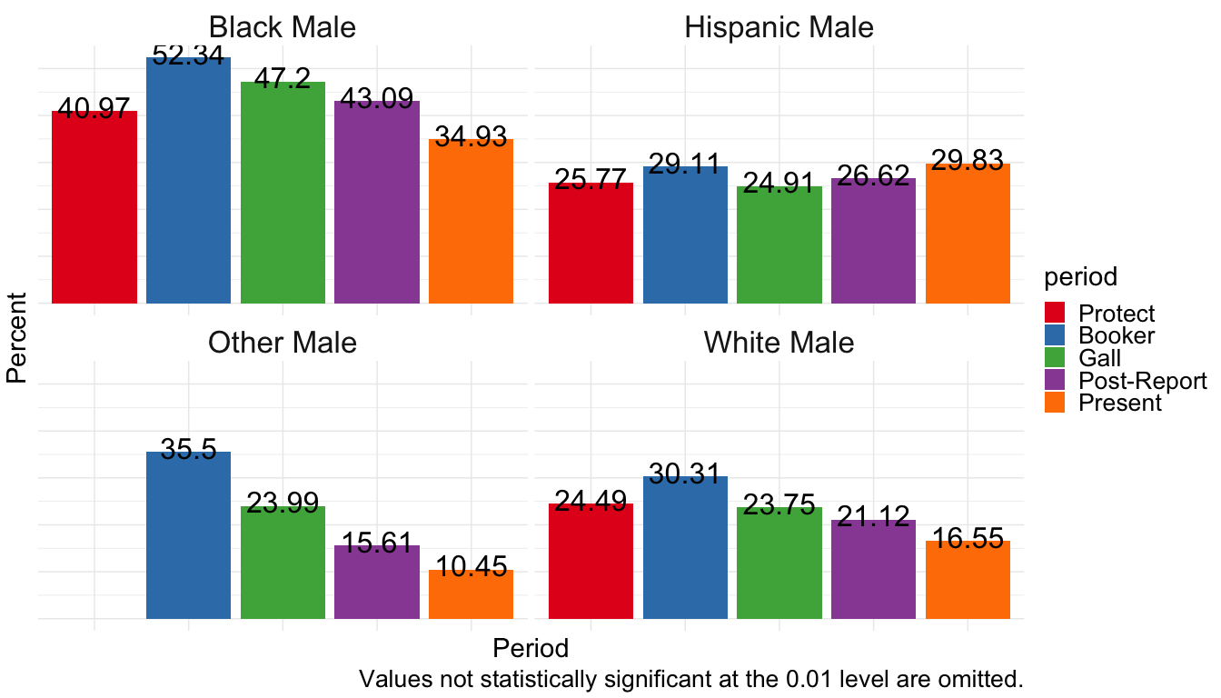

Black Female Baseline
